UW/CS/SP26/CYS-463/MLS
Department of Computer Science
UW Mid Semester LAB Sessional (Spring-2026)
(Group A)
Course Code: CYS-463L  Course Title: WEB Engineering(LAB)  Total Marks: 30  Date: 21-04-2026 | Name: Awais Asif  Registration No. UW-23-CY-BS-010  Discipline/Semester: BSCYS 6(N) Time allowed: 1 hr. 30 min.

NOTE:
-Attempt all the questions.
-All tasks will be submitted in a pdf file with file name [your name, registration No.].
-Maintain the order of the questions same as question paper in your answer sheet.
-Post Complete Report with Code, output on your LinkedIn & GitHub Profile.
-Understanding is part of paper.

Section 1 [LLO1, GA2, P1] [ 15 Marks]

Q1. Develop a Mini Student Web Portal consisting of multiple linked webpages.
You are required to design and implement a multi-page website where all pages are connected through navigation.
PART 1 – Registration Page
File: registration.html Requirements:
- Create a student registration form with:
  - Name o Email o Password o Confirm Password
  - Age o Gender
Functional Requirements:
- Apply Bootstrap styling
- Perform JavaScript validation: o Presence check (no empty fields) o Email format validation o Password match validation o Age must be numeric (type check) Navigation:
- After successful validation → redirect to Dashboard Page

Code:
<!DOCTYPE html>
<html>
<head>
<title>Registration</title>
<link href="https://cdn.jsdelivr.net/npm/bootstrap@5.3.0/dist/css/bootstrap.min.css" rel="stylesheet">
<script src="script.js"></script>
</head>
<body>

<div class="container mt-5">
<h2>Student Registration</h2>

<form onsubmit="return validateForm()">
<input type="text" id="name" class="form-control mb-2" placeholder="Name">
<input type="email" id="email" class="form-control mb-2" placeholder="Email">
<input type="password" id="password" class="form-control mb-2" placeholder="Password">
<input type="password" id="confirmPassword" class="form-control mb-2" placeholder="Confirm Password">
<input type="text" id="age" class="form-control mb-2" placeholder="Age">

<select id="gender" class="form-control mb-3">
<option value="">Select Gender</option>
<option>Male</option>
<option>Female</option>
</select>

<button class="btn btn-primary">Register</button>
</form>
</div>

</body>
</html>

Output:
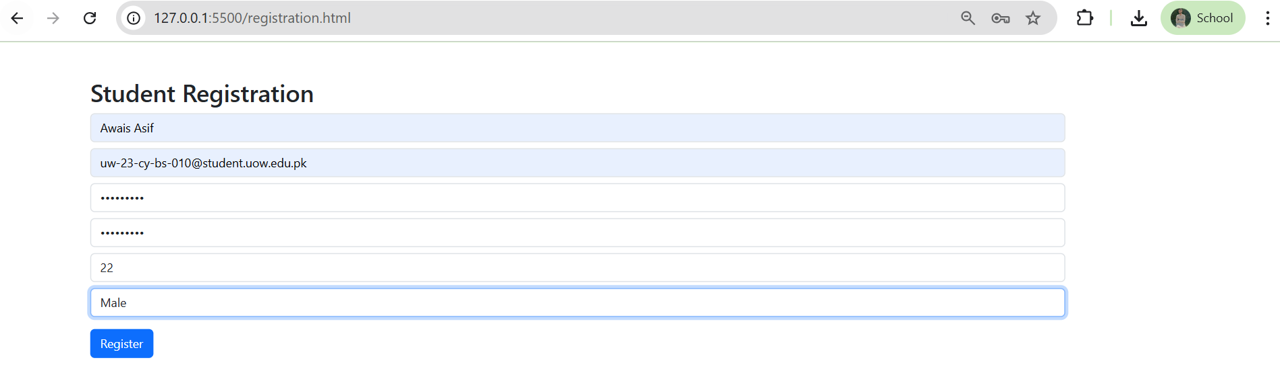
PART 2 – Dashboard Page File: dashboard.html Requirements:
• Display:

o Welcome message (using JavaScript) o Student Name (pass or simulate data)
- Use Bootstrap Navbar & Cards Functional Requirements:
- Button: Show Current Date & Time • Navigation links to: o Courses Page o Feedback Page
o Home Page

Code:
Dashboard.html
<!DOCTYPE html>
<html>
<head>
<title>Dashboard</title>
<link href="https://cdn.jsdelivr.net/npm/bootstrap@5.3.0/dist/css/bootstrap.min.css" rel="stylesheet">
<script src="script.js"></script>
</head>
<body onload="welcomeUser()">

<nav class="navbar navbar-dark bg-dark">
<div class="container">
<a class="navbar-brand">Dashboard</a>
<div>
<a href="courses.html" class="btn btn-light">Courses</a>
<a href="feedback.html" class="btn btn-light">Feedback</a>
<a href="index.html" class="btn btn-light">Home</a>
</div>
</div>
</nav>

<div class="container mt-5">
<h2 id="welcome"></h2>

<div class="card p-3">
<button class="btn btn-success" onclick="showDate()">Show Date & Time</button>
<p id="date"></p>
</div>
</div>

</body>
</html>
Output:
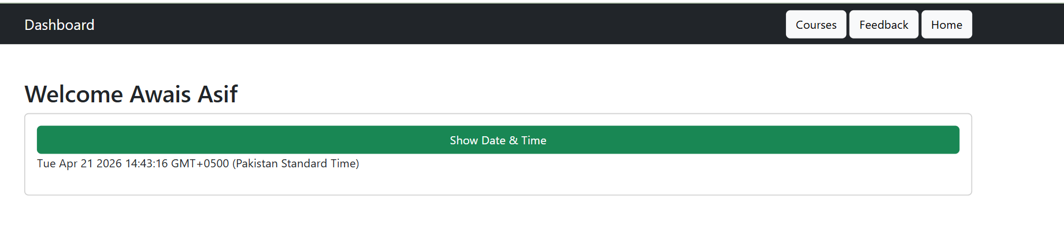
Script.js
Code:
function validateForm() {
let name = document.getElementById("name").value;
let email = document.getElementById("email").value;
let pass = document.getElementById("password").value;
let cpass = document.getElementById("confirmPassword").value;
let age = document.getElementById("age").value;
let gender = document.getElementById("gender").value;

if (!name || !email || !pass || !cpass || !age || !gender) {
alert("All fields required");
return false;
}

if (!email.includes("@")) {
alert("Invalid email");
return false;
}

if (pass !== cpass) {
alert("Passwords do not match");
return false;
}

if (isNaN(age)) {
alert("Age must be number");
return false;
}

localStorage.setItem("username", name);

window.location.href = "dashboard.html";
return false;
}

function welcomeUser() {
let name = localStorage.getItem("username");
document.getElementById("welcome").innerText = "Welcome " + name;
}

function showDate() {
document.getElementById("date").innerText = new Date();
}

function showCourses() {
let selected = [];
let checkboxes = document.querySelectorAll("input[type=checkbox]:checked");

checkboxes.forEach(c => selected.push(c.value));

alert("Selected: " + selected.join(", "));
}

function feedbackValidation() {
let name = document.getElementById("fname").value;
let comment = document.getElementById("comment").value;
let rating = document.getElementById("rating").value;

if (!name || !comment || !rating) {
alert("All fields required");
return false;
}

alert("Feedback Submitted Successfully");
return false;
}

PART 3 – Course Selection Page
File: courses.html Requirements:
- Display course list using checkboxes:
  - Web Development
  - Artificial Intelligence o Database Systems o Mobile App Development Functional Requirements: • Button: Submit Courses • On click: o Show selected courses using alert Navigation:
- Link back to Dashboard

Code:
<!DOCTYPE html>
<html>
<head>
<title>Courses</title>
<link href="https://cdn.jsdelivr.net/npm/bootstrap@5.3.0/dist/css/bootstrap.min.css" rel="stylesheet">
<script src="script.js"></script>
</head>
<body>

<div class="container mt-5">
<h2>Select Courses</h2>

<input type="checkbox" value="Web Development"> Web Development<br>
<input type="checkbox" value="AI"> Artificial Intelligence<br>
<input type="checkbox" value="DB"> Database Systems<br>
<input type="checkbox" value="Mobile"> Mobile App Development<br><br>

<button class="btn btn-primary" onclick="showCourses()">Submit</button>
<br><br>
<a href="dashboard.html">Back to Dashboard</a>
</div>

</body>
</html>

Output:
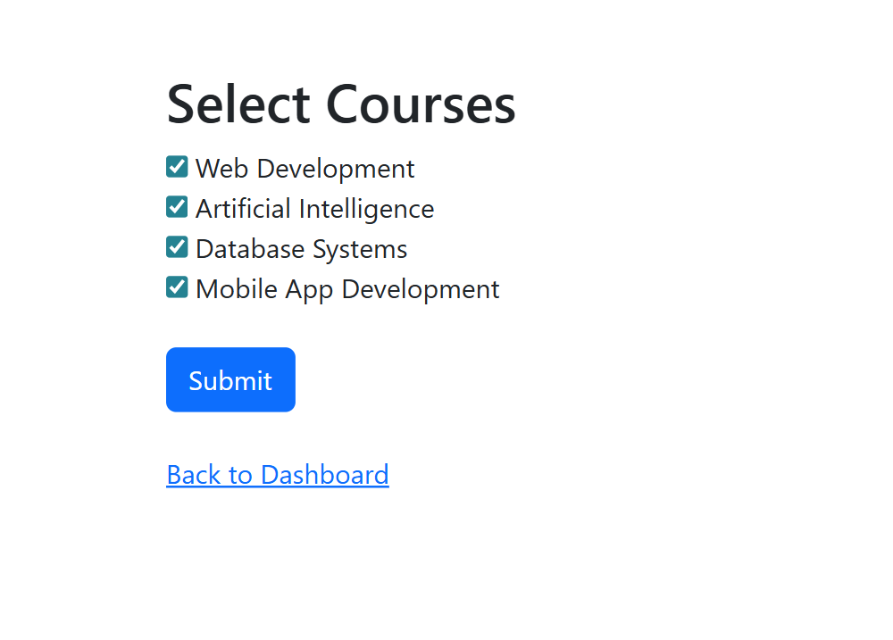
PART 4 – Feedback Page File: feedback.html Requirements:
- Form fields:
o Name o Comments o Rating (Dropdown) Functional Requirements:
- Apply validation (presence check)
- Show success message after submission Navigation:
- Link back to Dashboard

Code:
<!DOCTYPE html>
<html>
<head>
<title>Feedback</title>
<link href="https://cdn.jsdelivr.net/npm/bootstrap@5.3.0/dist/css/bootstrap.min.css" rel="stylesheet">
<script src="script.js"></script>
</head>
<body>

<div class="container mt-5">
<h2>Feedback</h2>

<form onsubmit="return feedbackValidation()">
<input type="text" id="fname" class="form-control mb-2" placeholder="Name">
<textarea id="comment" class="form-control mb-2" placeholder="Comments"></textarea>

<select id="rating" class="form-control mb-3">
<option value="">Rating</option>
<option>Excellent</option>
<option>Good</option>
<option>Average</option>
</select>

<button class="btn btn-success">Submit</button>
</form>

<br>
<a href="dashboard.html">Back to Dashboard</a>
</div>

</body>
</html>

Output:
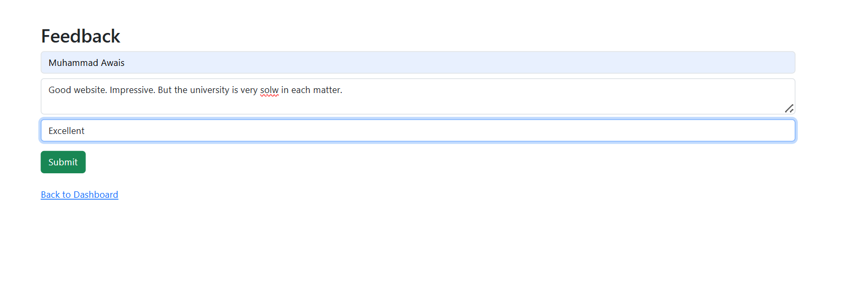
PART 5 – MAIN PAGE (Home Page)
File: index.html Requirements:
• Create a homepage with:
Energy saved is energy gained—embrace efficiency and be a beacon of change in your community.

o Website title: Student Portal o Navigation bar (Bootstrap) Navigation Links:
- Registration
- Dashboard
- Courses
- Feedback Design:
- Apply CSS styling
- Add hover effects or basic UI enhancements

Code:
<!DOCTYPE html>
<html>
<head>
<title>University Student Portal</title>
<link rel="stylesheet" href="style.css">
<link href="https://cdn.jsdelivr.net/npm/bootstrap@5.3.0/dist/css/bootstrap.min.css" rel="stylesheet">
</head>
<body>

<nav class="navbar navbar-dark bg-dark navbar-expand-lg">
<div class="container">
<a class="navbar-brand">UniversityStudent Portal</a>
<div>
<a href="registration.html" class="btn btn-light">Registration</a>
<a href="dashboard.html" class="btn btn-light">Dashboard</a>
<a href="courses.html" class="btn btn-light">Courses</a>
<a href="feedback.html" class="btn btn-light">Feedback</a>
</div>
</div>
</nav>

<div class="container text-center mt-5">
<h1>Welcome to University Student Portal</h1>
<p>This is your University student Potal. Manage your courses and feedback easily</p>
</div>

</body>
</html>
Style.css
body {
background-color: #f4f4f4;
}

h1, h2 {
color: #333;
}

a:hover {
background-color: #0d6efd;
color: white !important;
}

Output:
